Create file share through the Azure portal

1. **Go to Storage Account blade on Azure portal**:  
   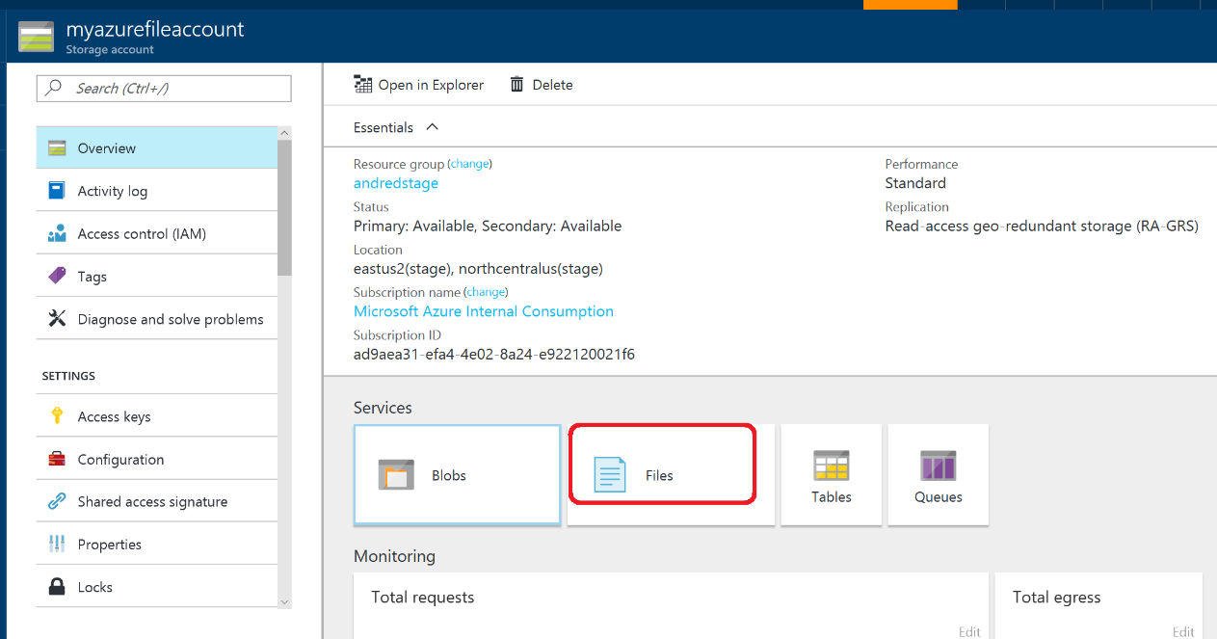
2. **Click on add File Share button**:  
   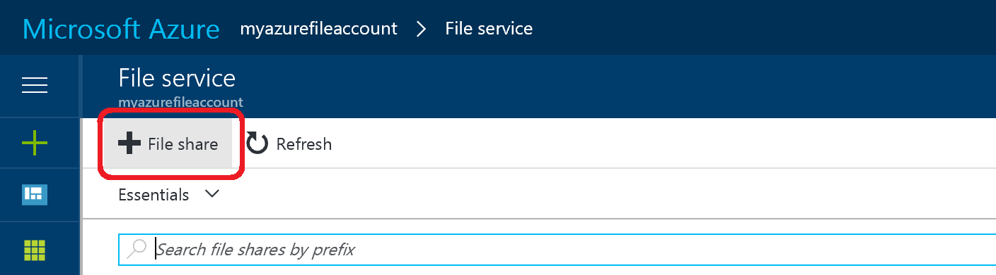
3. **Provide Name and Quota. Quota currently can be maximum 5 TiB**:  
   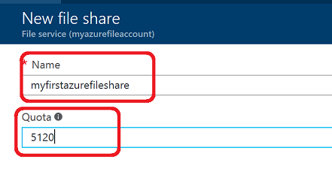
4. **View your new file share**: 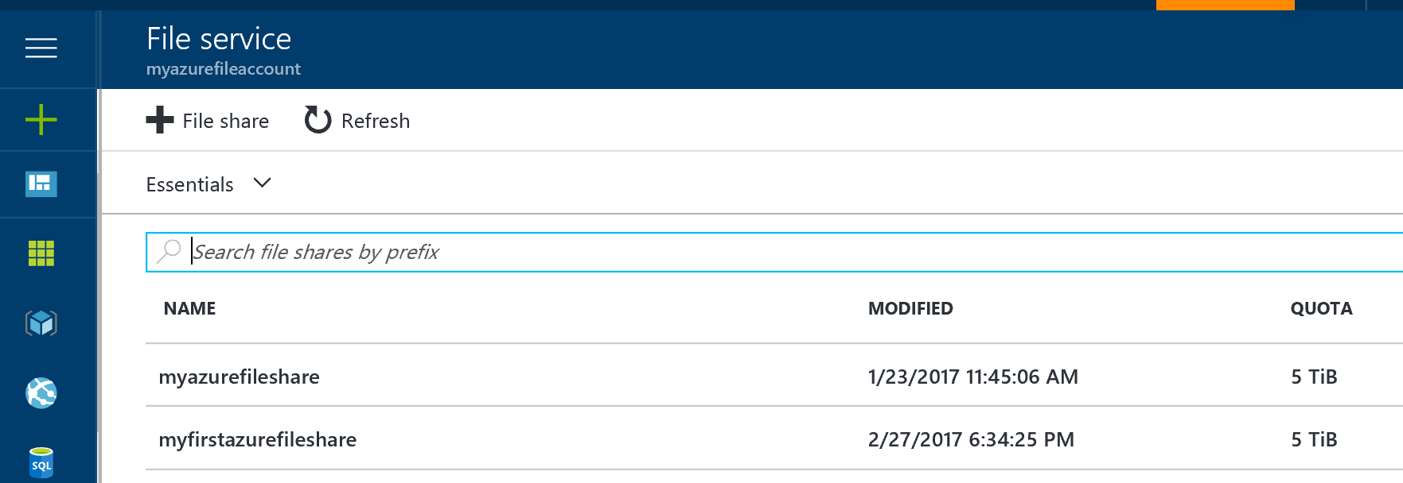
5. **Upload a file**: 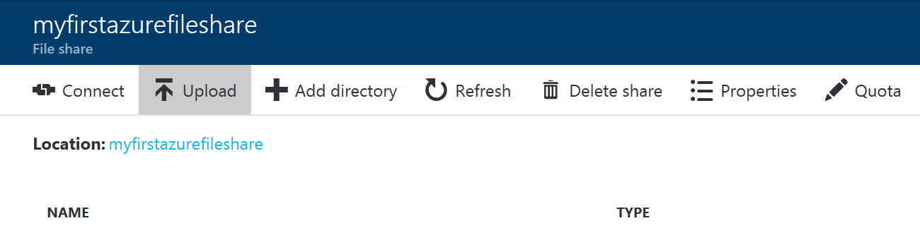
6. **Browse into your file share and manage your directories and files**: 